Welcome! This is a brief picture walk-through to help you know what to expect and where to go for your group session. You'll find step-by-step images showing the entrance, key landmarks, and the room where your session will be held.
Follow the path outlined to ensure a smooth arrival, and if you have any questions along the way, feel free to reach out. We look forward to seeing you soon!
The Little Black Duck is located within The Develop and Grow Psychology and Health offices, at 418 Wilson st Albury.
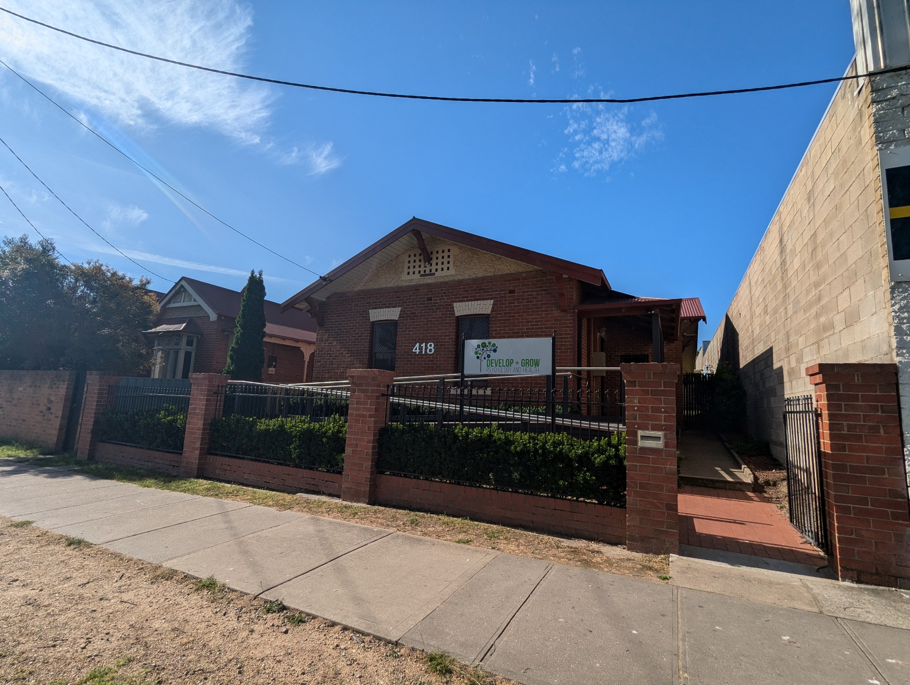

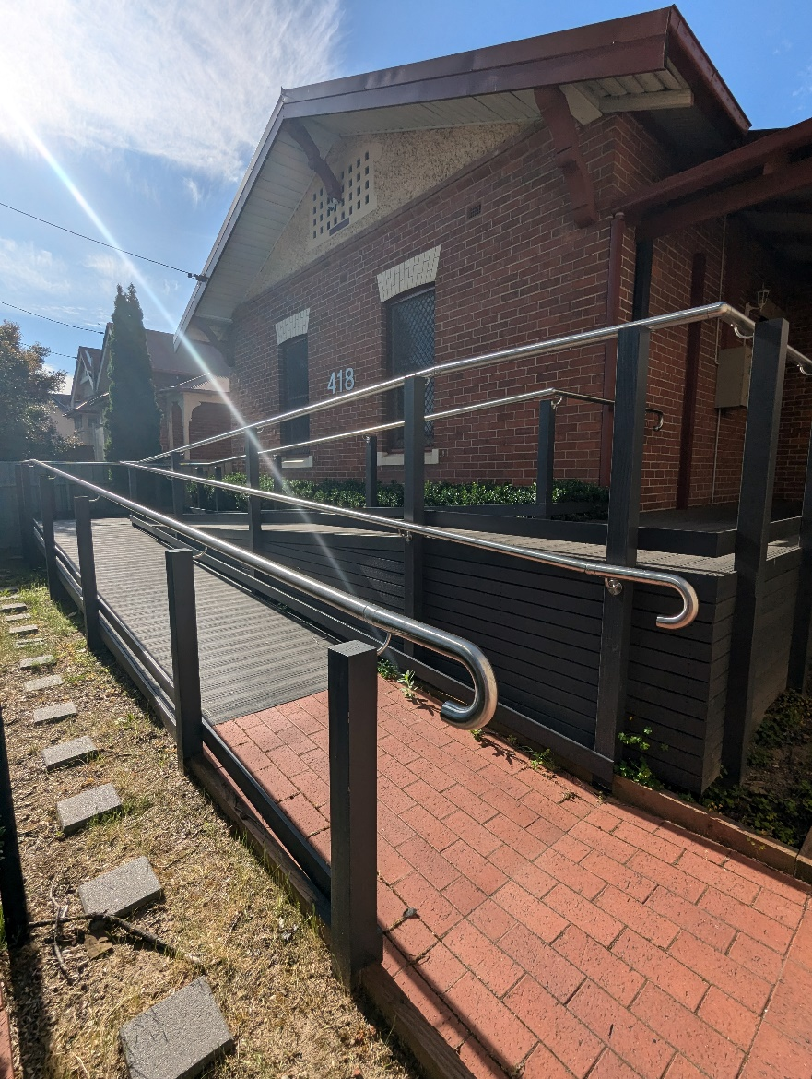
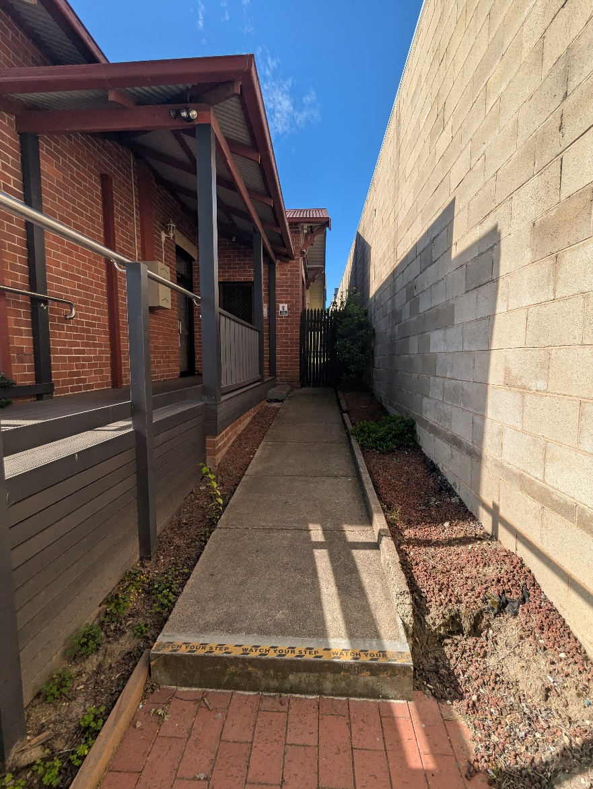
When you entre through the black gate, you will see two ways to access the front door, the ramp, with safety rails, or the footpath, which has three steps total until you’re at the front door.

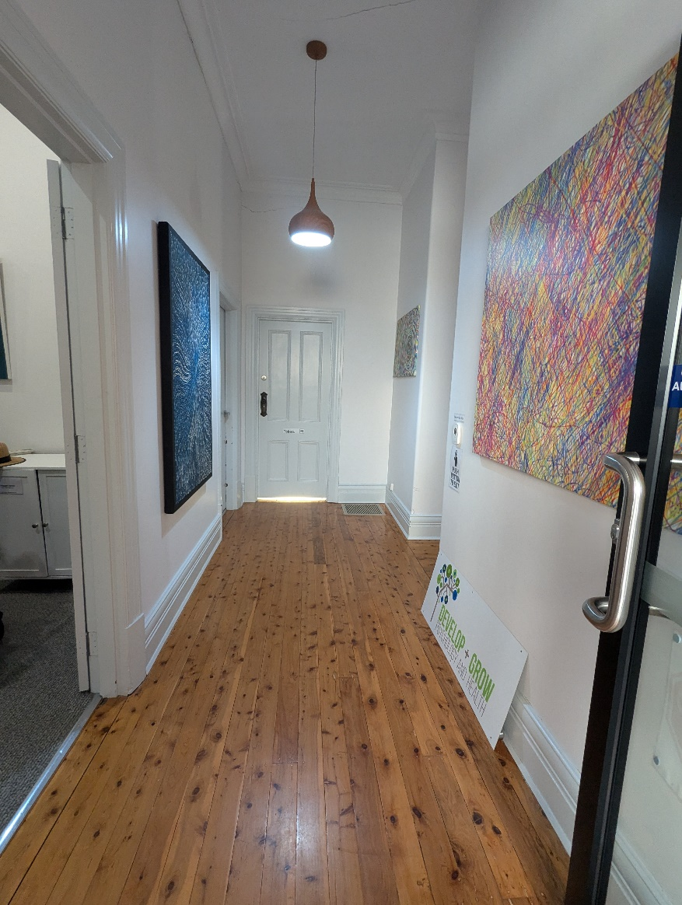
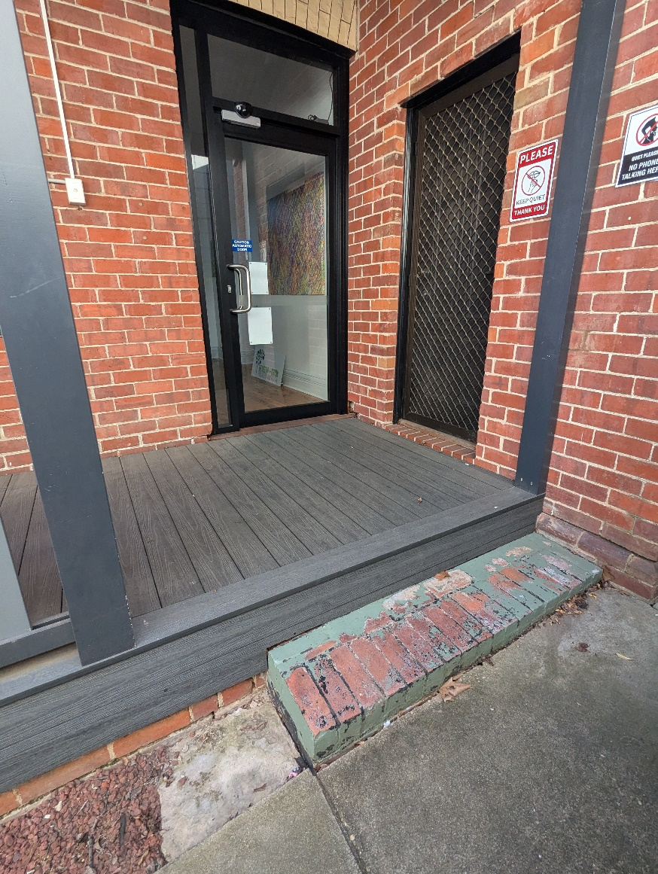
The front door is the glass door and is automatic when opening, all you need to do is walk in front of it and it will open inwards (away from you)
You will then be at the start of the hallway. The toilet is straight ahead, and Little Black Duck is to the left of the toilet.

Here you will see The main office for The Little Black duck and the toilet. If you turn right down the hall way, you’ll see the waiting space (also reception for Develop and Grow. The social groups are held in the back office, to get there you exit through the back door.)
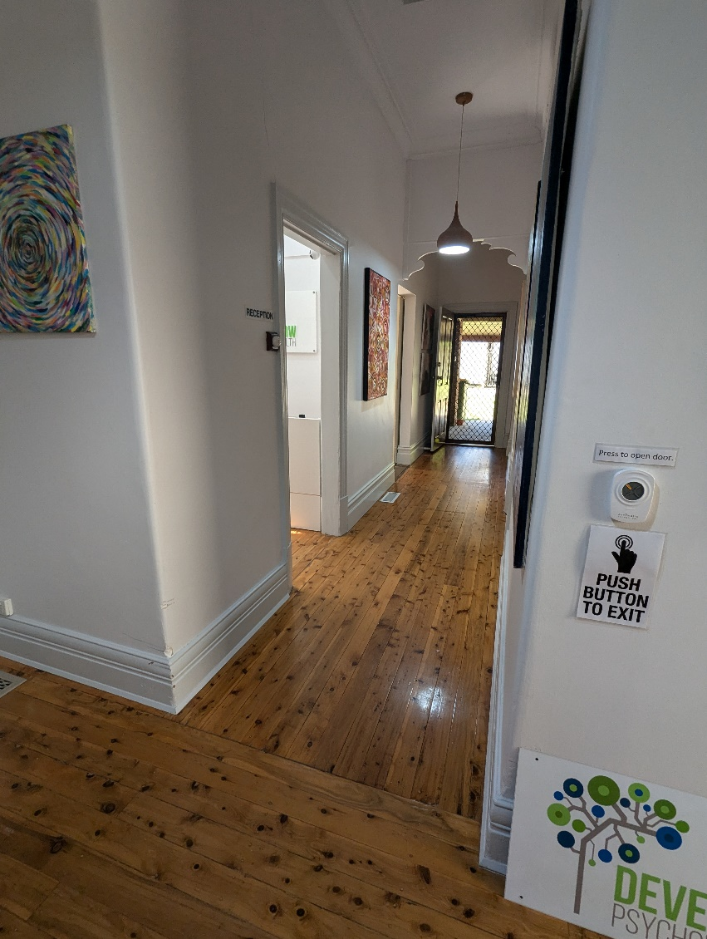
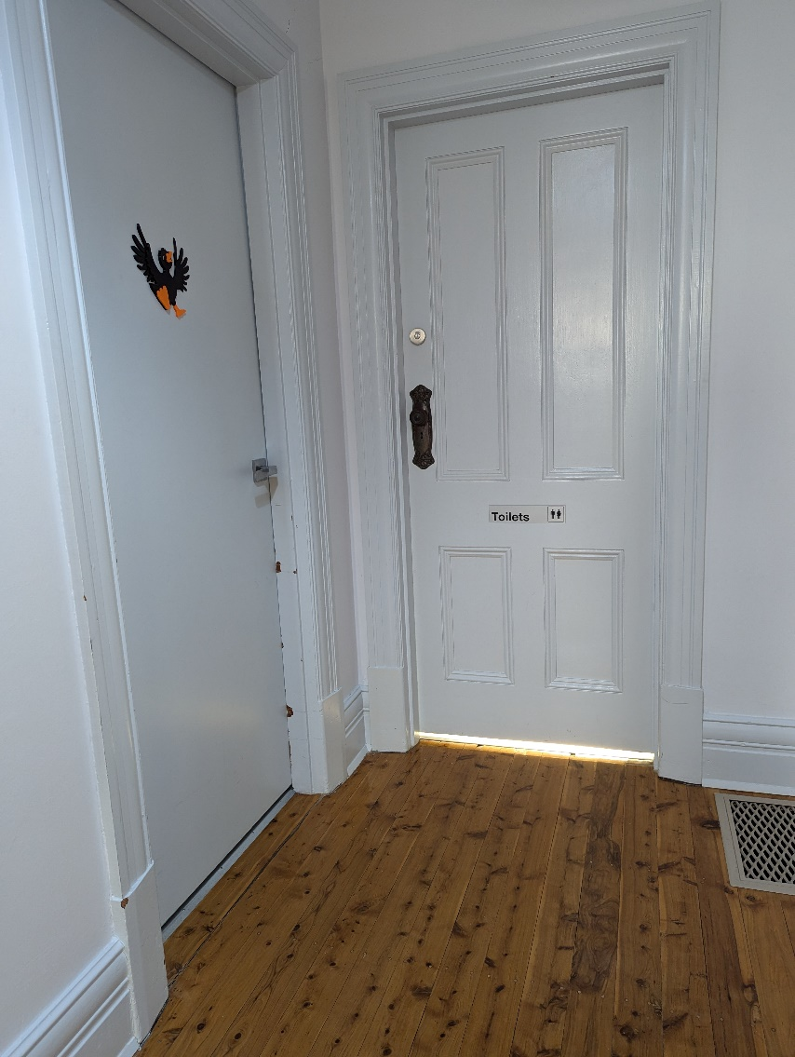

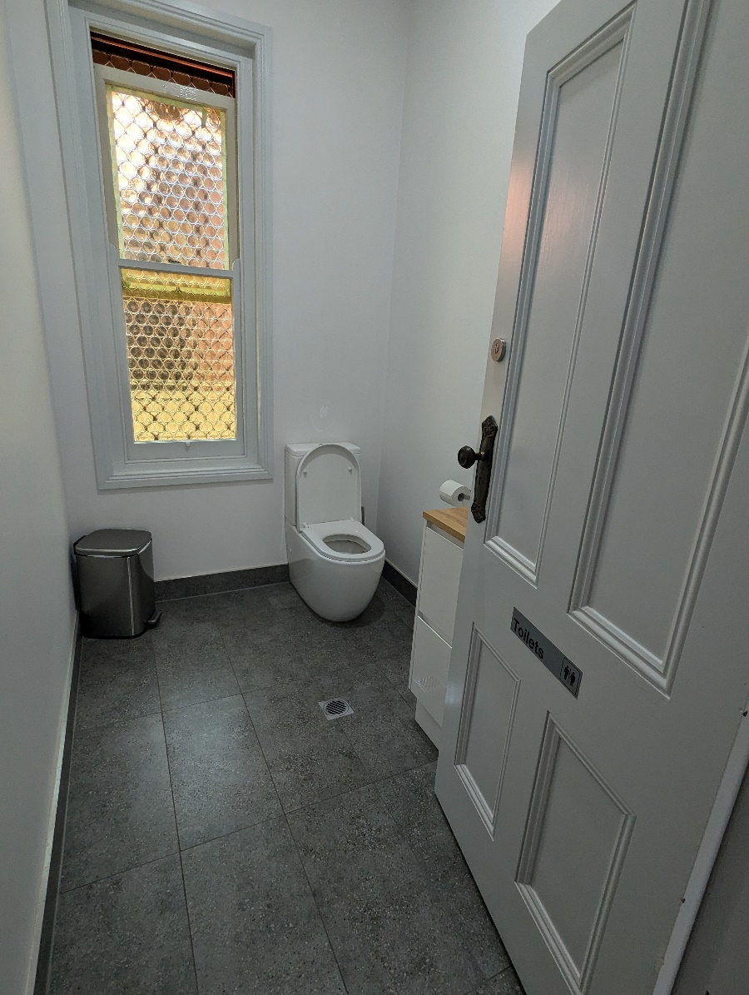
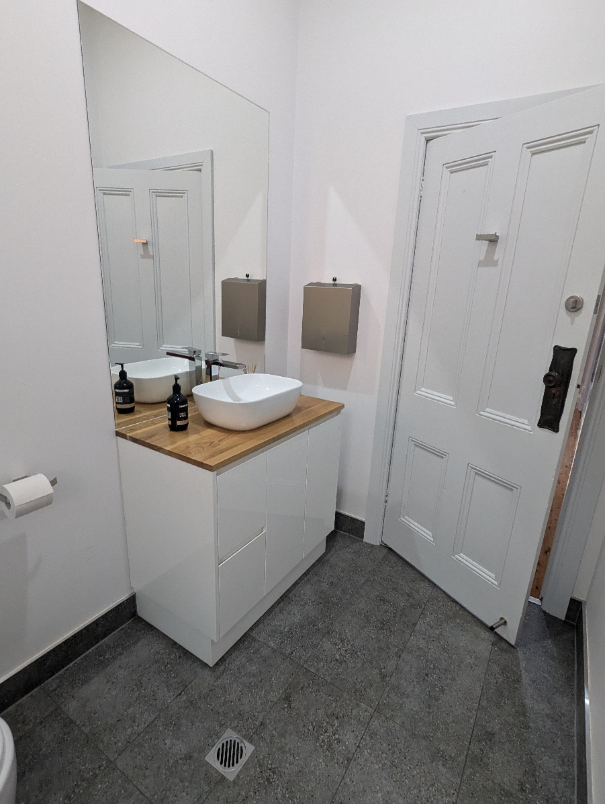
This is the main toilet, should you need access to an accessible bathroom, please let us know and we can provide more detail.

When you start to walk down the hallway towards the back door, on your left there will be a waiting room/reception space with three chairs and some thing to play with. Please wait here while waiting for the Therapy Assistant to collect you.
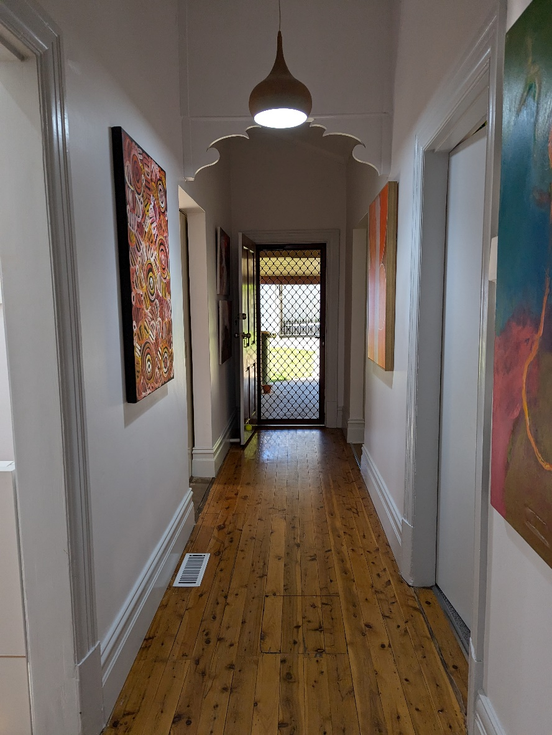
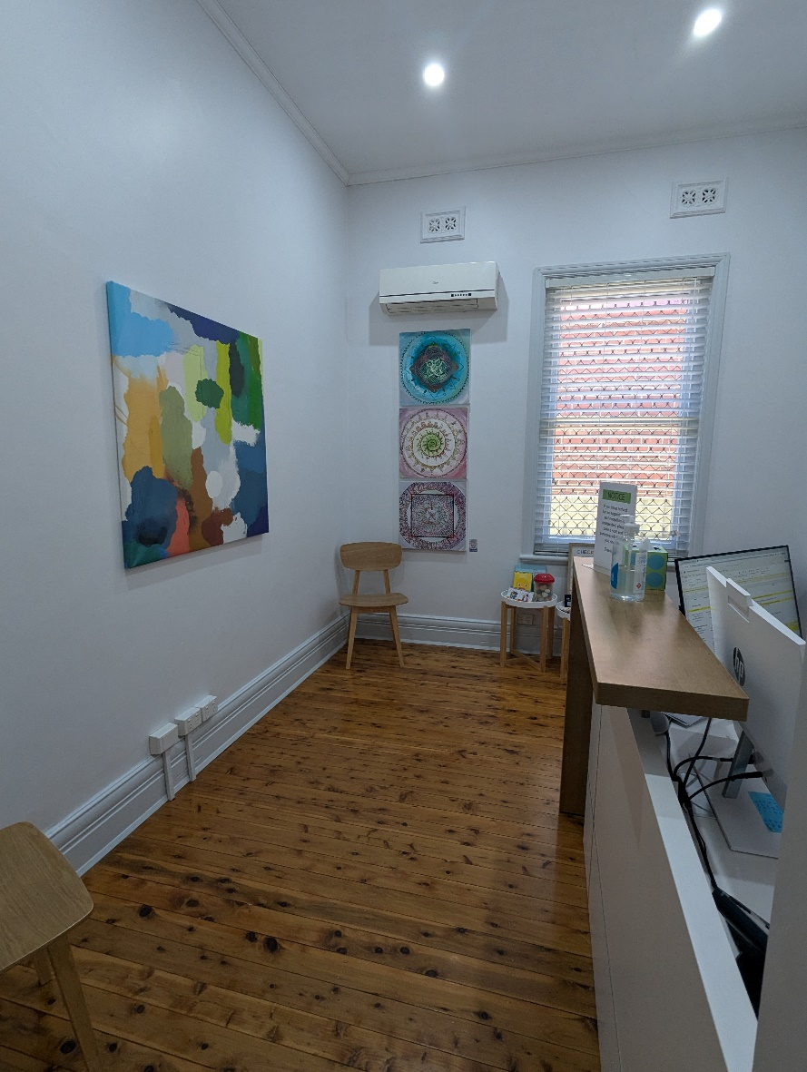

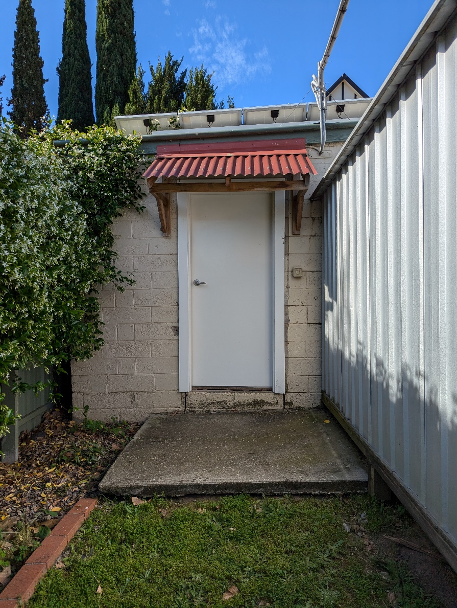
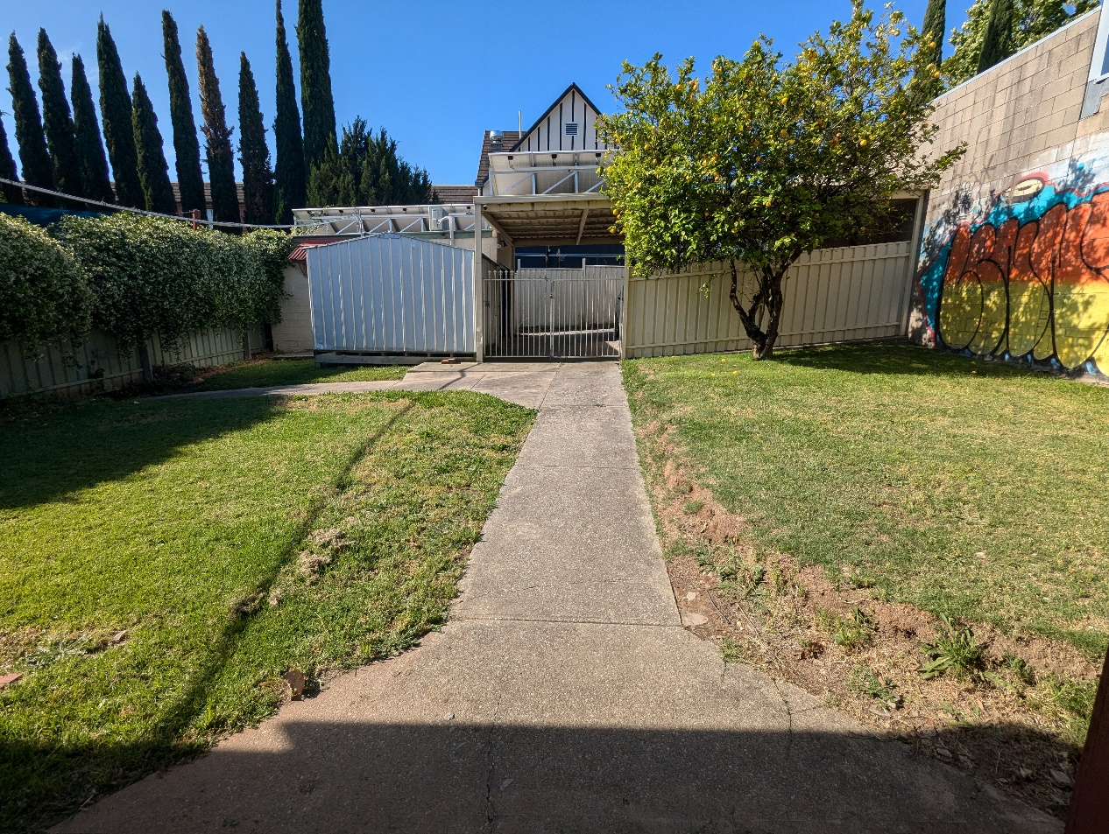
When you exit through the back door (with fly screen) you’ll come out to the backyard. From here you can follow the footpath straight and to the left to the white door for the detached room. This is where the group sessions will be.

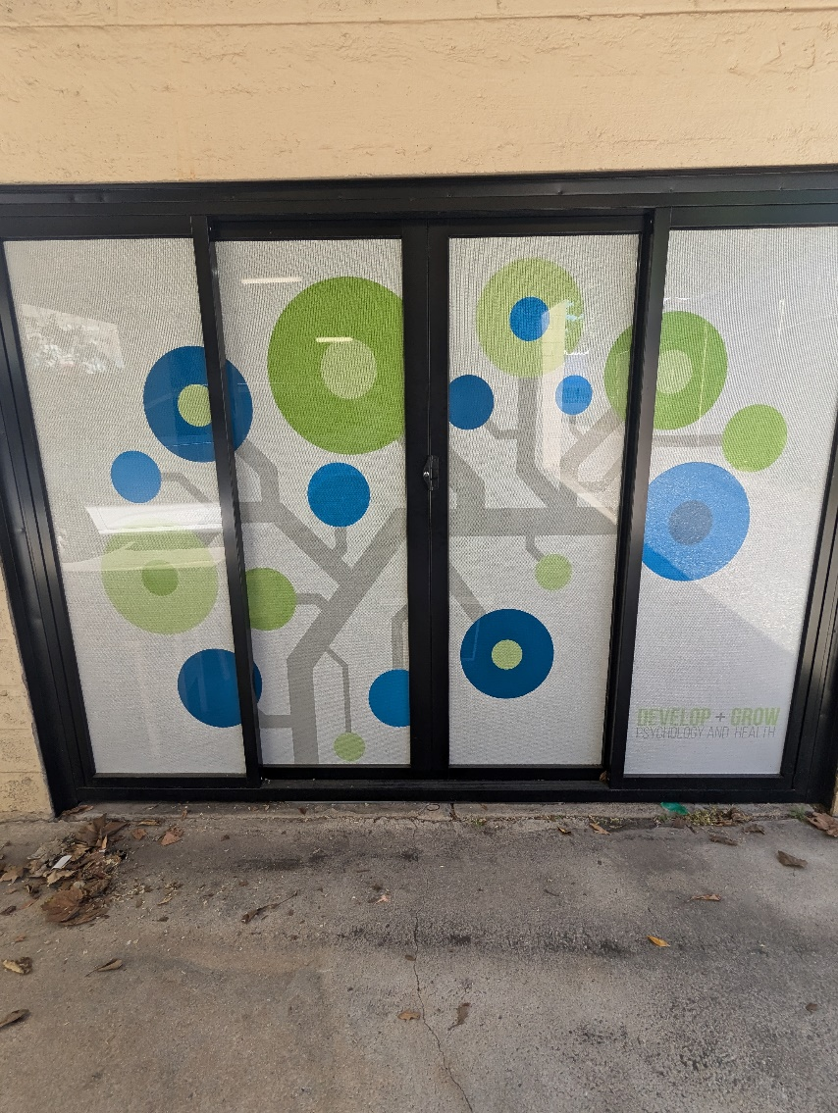
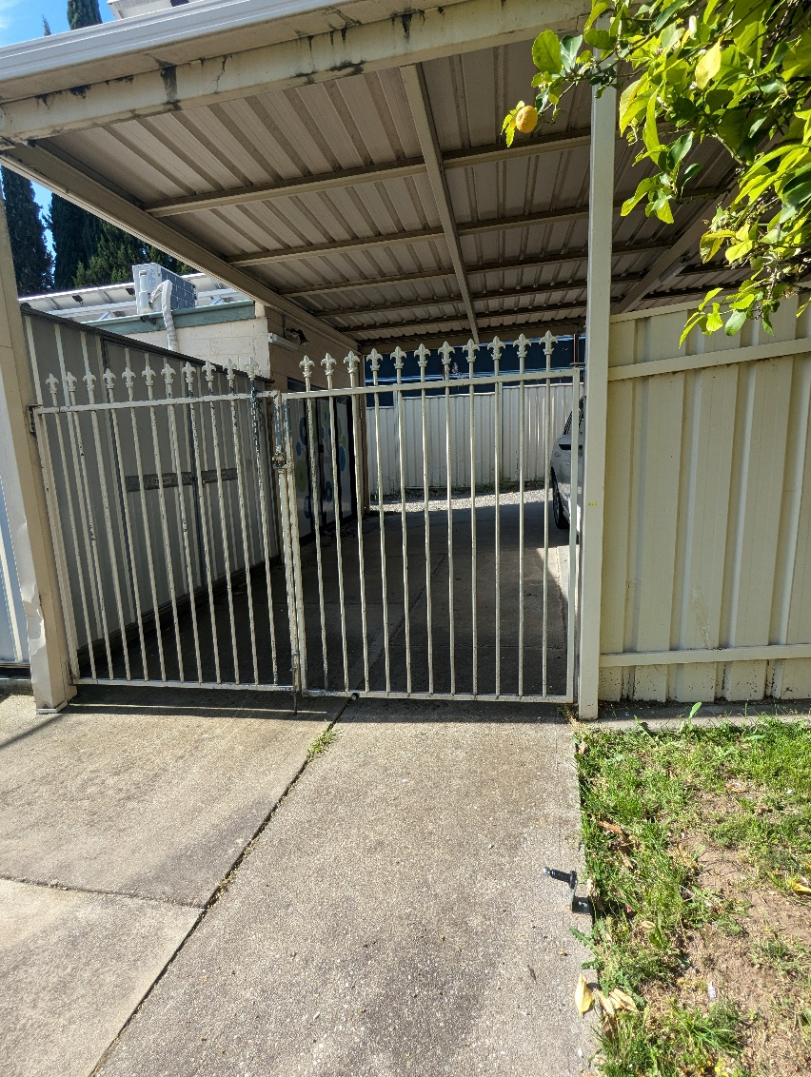
Should you need easier access, you can go through the gate, and entre through the sliding doors with the white background and coloured circles on it, please note that there is raised runners for the doors white mean you will need to step over them. There may be a car parked in this area as well so please ensure to be mindful. Should you require smoother access to this door, please let us know and we can provide you with more information.

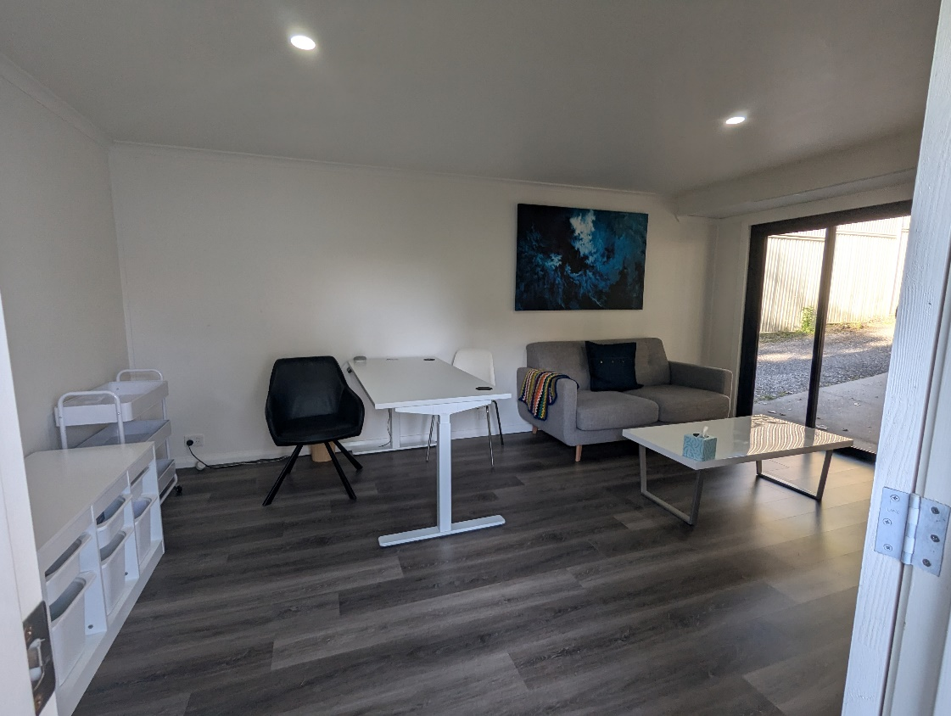
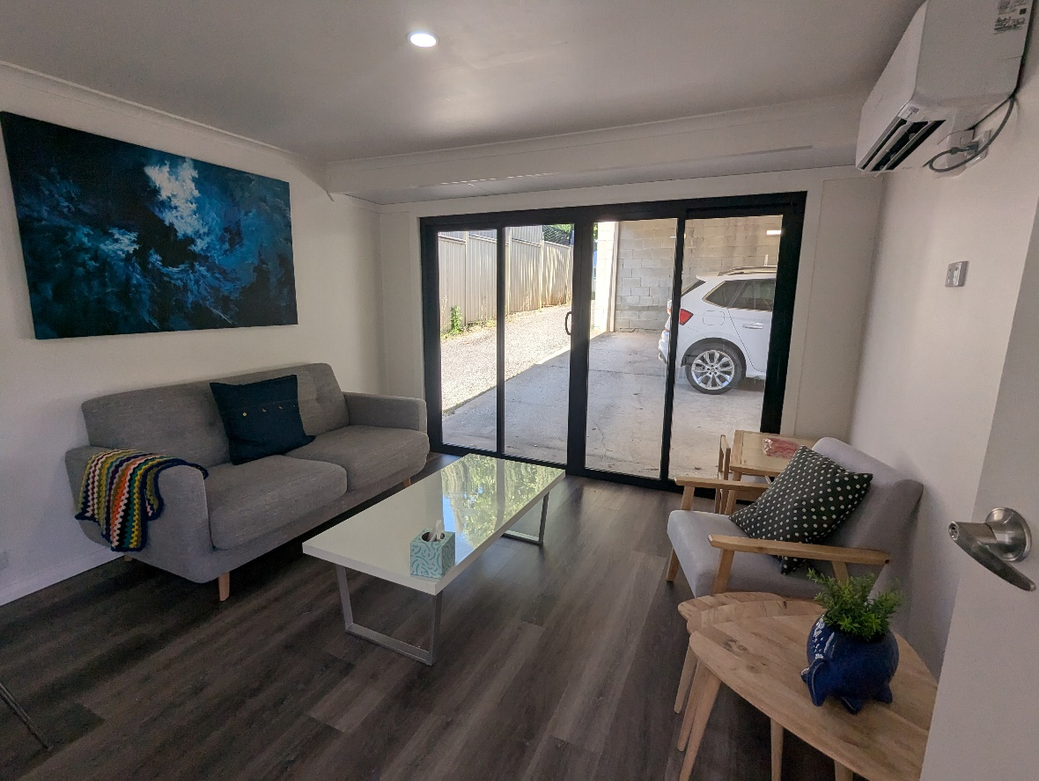
This is the room for the group sessions. Please know the furniture may move around, depending on need for activities, and some pieces might even be removed to provide more space. If this is something that might cause anxiety, please let us know so we can best accommodate for this.

When leaving, or going to the bathroom, from the white door, you’ll go back to the path, up to the main building, and through the back door with the fly screen
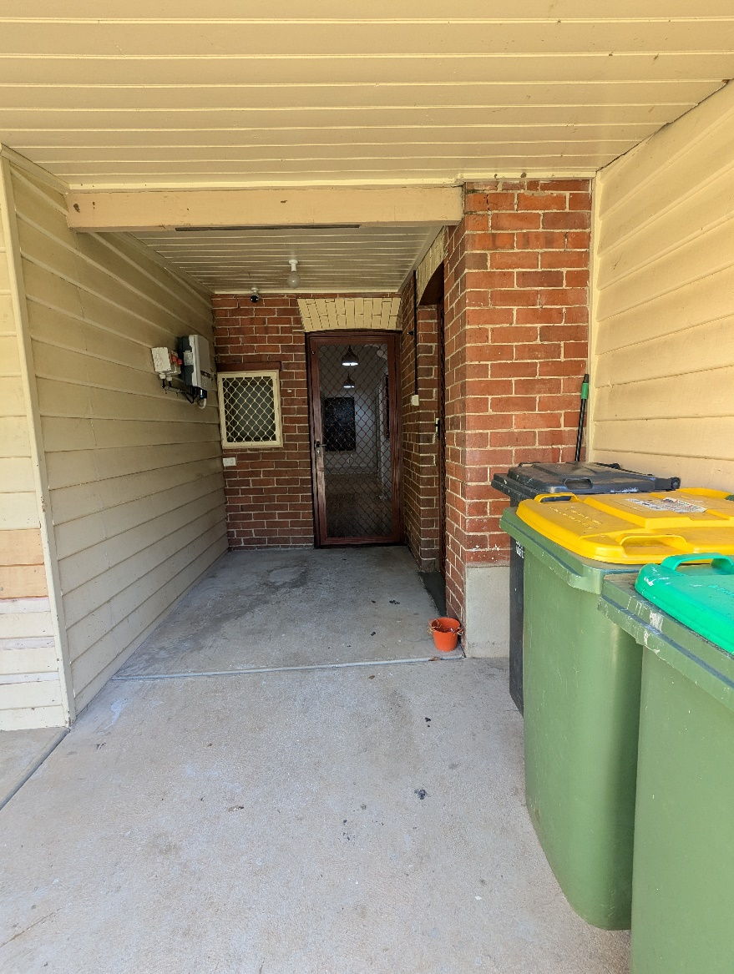
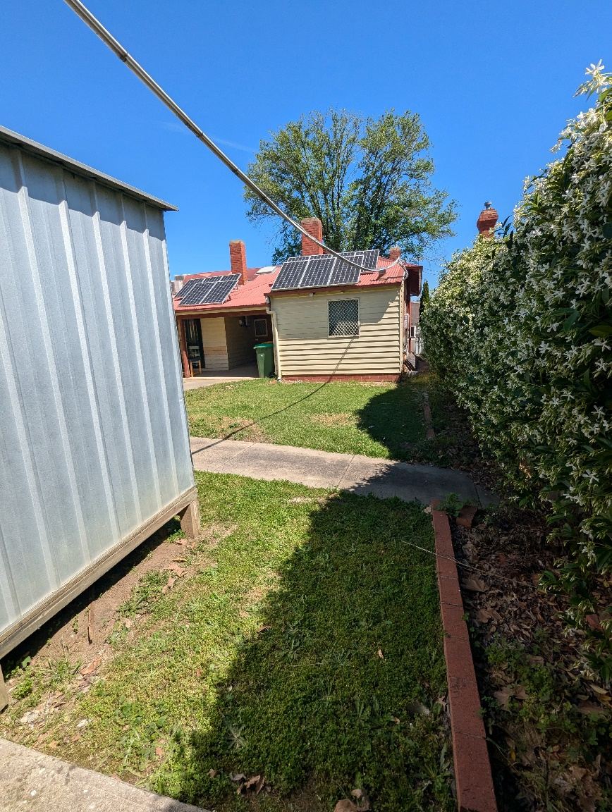

You’ll follow the hallway back towards the front door, which will be on your left once you get to the top of the hallway. If you turn right, you’ll see the toilet and office for The Little Black Duck.

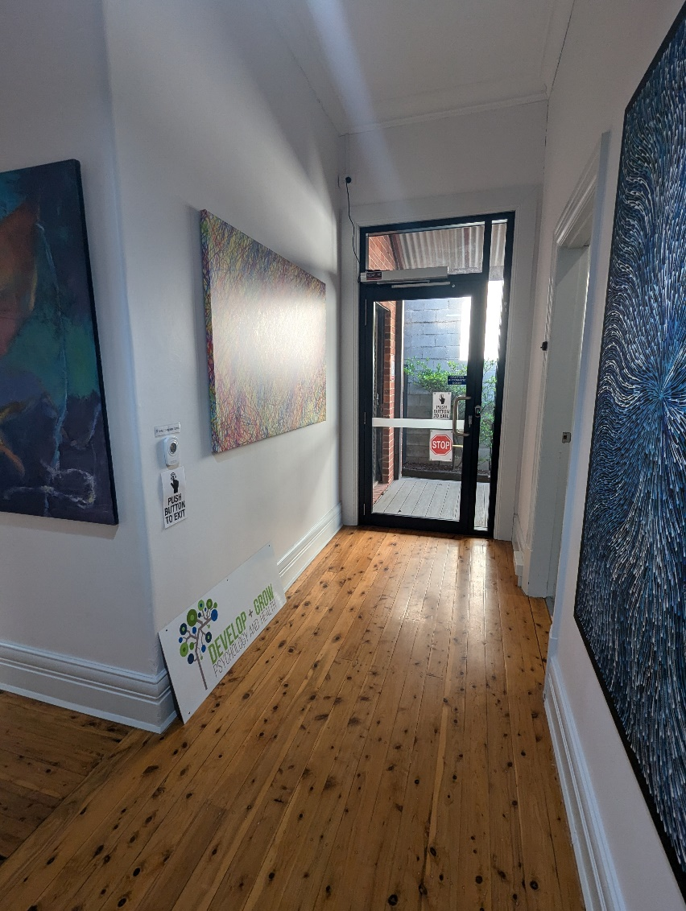
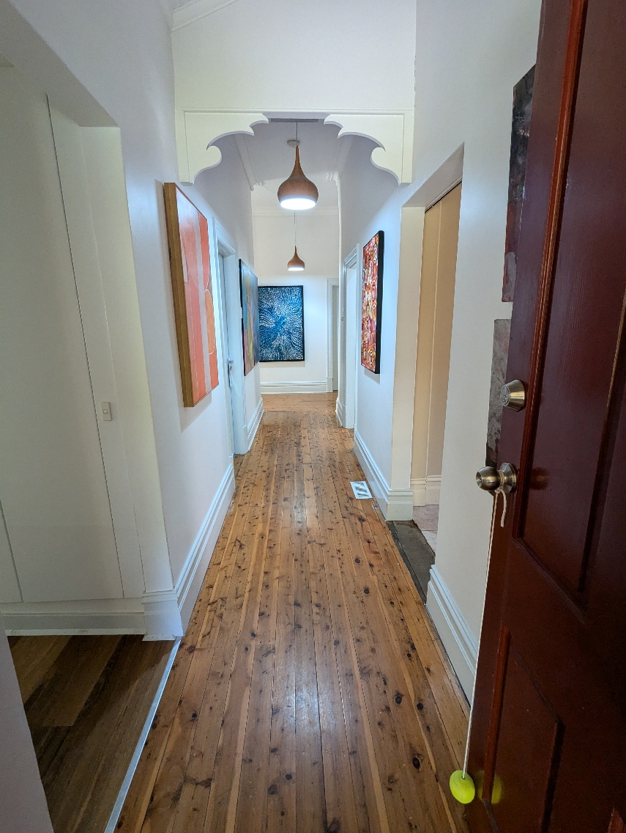

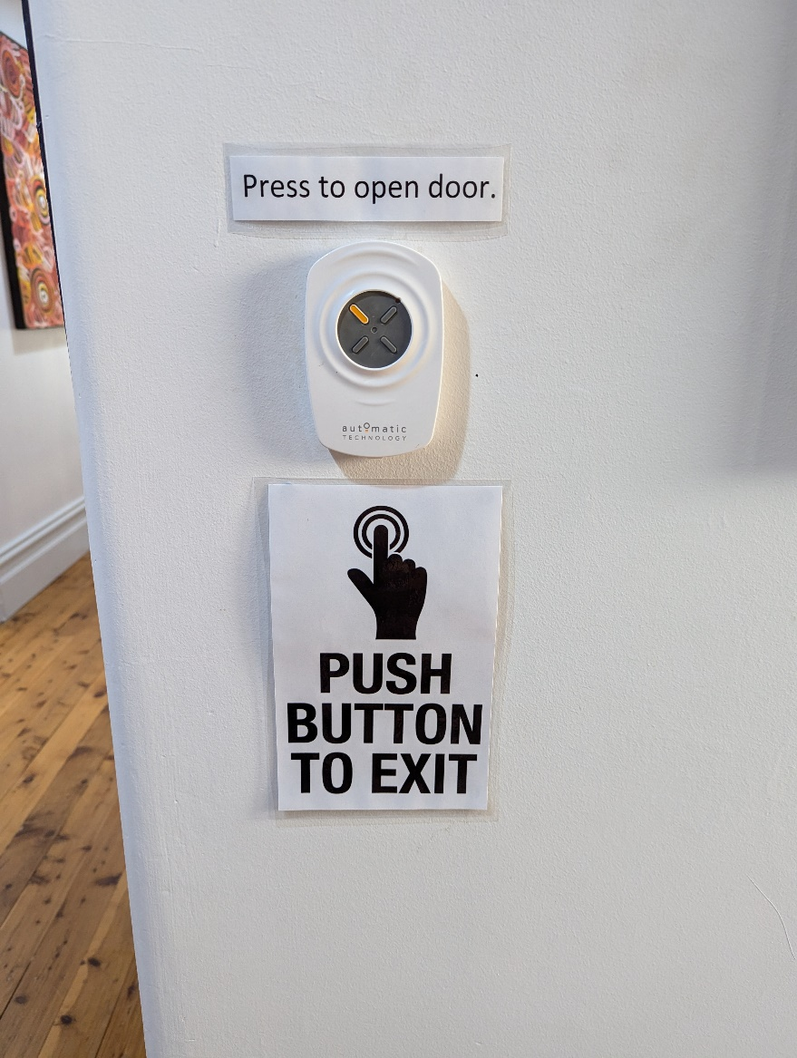
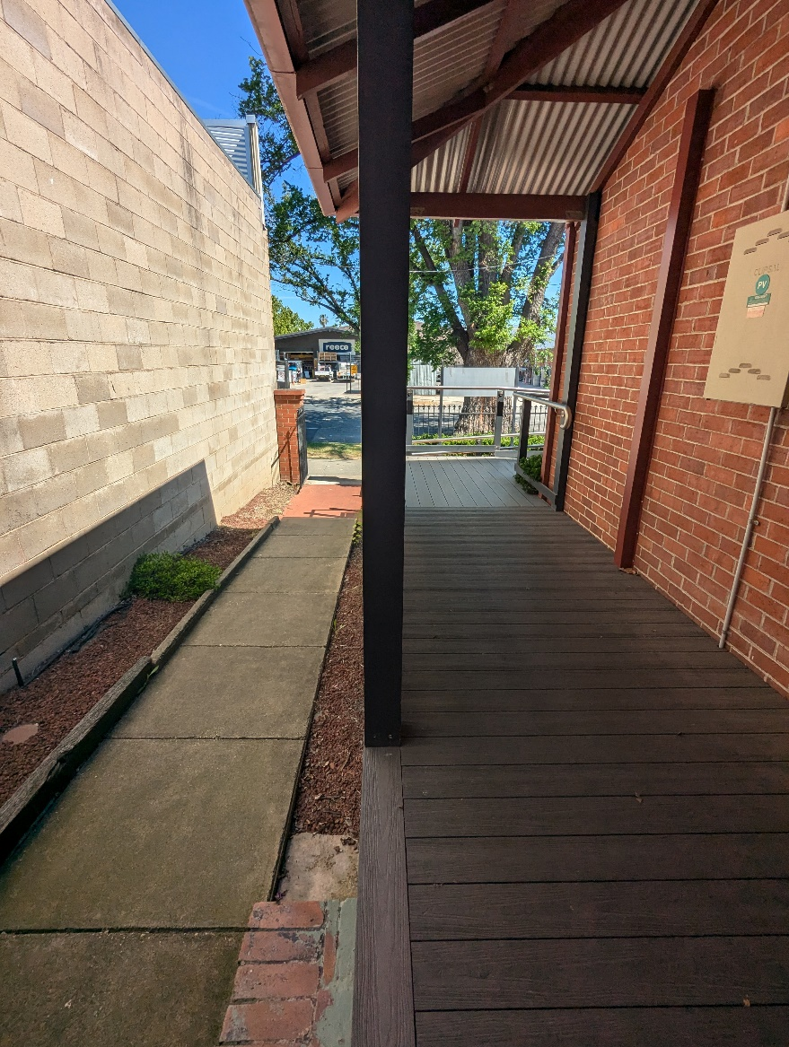
Be sure to push the yellow/orange button that will be on your left, when facing the door. The door will swing towards you so be sure to leave space. Once leaving you’ll go back out the gate to the main street.

